Client Project
“Customer Segmentation Project (CDACL-002)”
Project Title –
Customer Segmentation on U.S. Shooper Purchase Data
Project Id –
PTID-CDA-NOV-25-862
Course Name - CDA
Names -
Anil Kumar Tiwari

Introduction:

This project is based on Customer Segmentation and Shopping Trend Analysis, with the main objective being to analyze customer shopping behavior.
1. Background: In today's competitive e-commerce market, it is crucial for every business to understand who their customers are, what they buy, and how they buy. The goal of this analysis is to derive data-driven insights that can help businesses make better marketing and inventory decisions.
This project is based on Customer Segmentation and Shopping Trend Analysis, with the main purpose being to analyze customer shopping behavior.
2. Data Source: This project used the "Shopping Trends" dataset containing 3900 records. It includes essential customer information such as:
Customer Age, Gender, and Location.
Purchase Amount (USD) and Item Category.
Payment Method, Discount Applied, and Frequency of Purchases.

3. Project Objectives (Goal): The following three main tasks have been completed in this report:
Task No. Objective (Goal) -
(i). Discount Strategy: To identify those product categories where applying discount is most beneficial.
(ii). Impact Analysis: To understand card spending based on customer age, and to find out the impact of seasons & locations on purchase.
(iii) . Customer Segmentation: To divide customers into 3 or more groups
(clusters)based on their shopping trends and prepare target marketing campaigns for each segment.

This report first performs data cleansing and exploratory analysis, and finally identifies customer segments using K-Means Clustering.

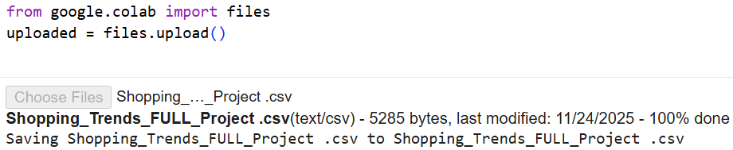


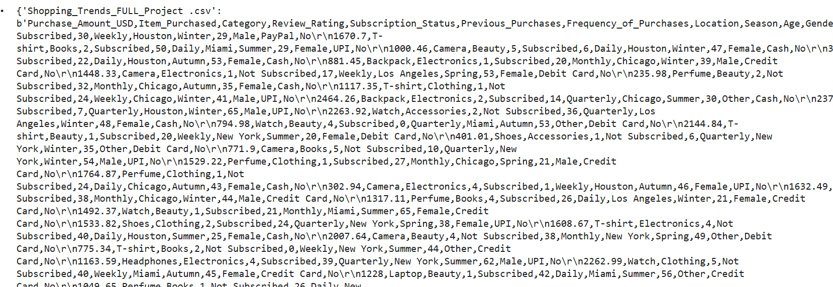
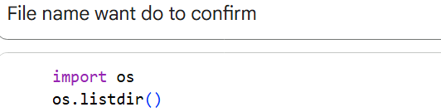
Output -
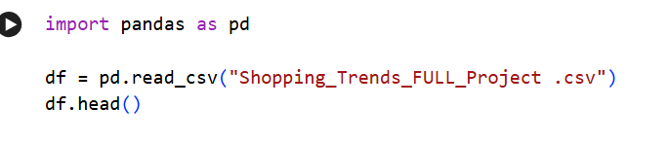
Output –
Purchase_Amount_USD | Item_Purchased | Category | Review_Rating | Subscription_Status | Previous_Purchases | Frequency_of_Purchases | Location | Season | Age | Gender | Payment_Method | Discount_Applied
0 | 685.61 | Shoes | Beauty | 2 | Not Subscribed | 30 | Weekly | Houston | Winter | 29 | Male | PayPal | No
1 | 1670.70 | T-shirt | Books | 2 | Subscribed | 50 | Daily | Miami | Summer | 29 | Female | UPI | No
2 | 1000.46 | Camera | Beauty | 5 | Subscribed | 6 | Daily | Houston | Winter | 47 | Female | Cash | No
3 | 386.03 | Watch | Electronics | 1 | Subscribed | 20 | Monthly | Chicago | Summer | 23 | Female | Cash | No
4 | 160.48 | Smartphone | Books | 2 | Not Subscribed | 22 | Daily | Houston | Autumn | 53 | Female | Cash | No

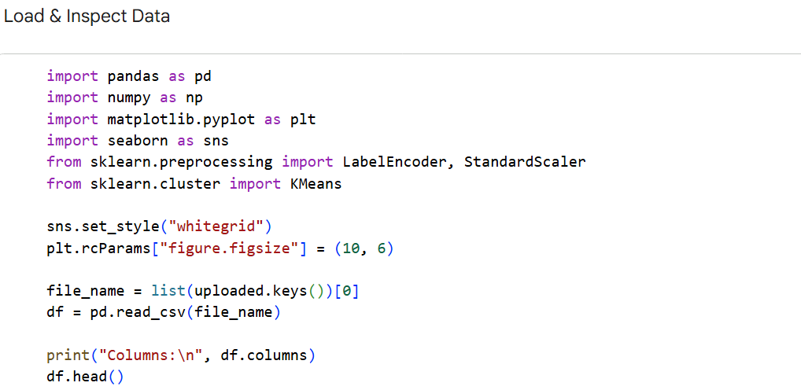

Output –
Columns:
Index(['Purchase_Amount_USD', 'Item_Purchased', 'Category', 'Review_Rating',
'Subscription_Status', 'Previous_Purchases', 'Frequency_of_Purchases',
'Location', 'Season', 'Age', 'Gender', 'Payment_Method',
'Discount_Applied'],
dtype='object')
 | Purchase_Amount_USD | Item_Purchased | Category | Review_Rating | Subscription_Status | Previous_Purchases | Frequency_of_Purchases | Location | Season | Age | Gender | Payment_Method | Discount_Applied
0 | 685.61 | Shoes | Beauty | 2 | Not Subscribed | 30 | Weekly | Houston | Winter | 29 | Male | PayPal | No
1 | 1670.70 | T-shirt | Books | 2 | Subscribed | 50 | Daily | Miami | Summer | 29 | Female | UPI | No
2 | 1000.46 | Camera | Beauty | 5 | Subscribed | 6 | Daily | Houston | Winter | 47 | Female | Cash | No
3 | 386.03 | Watch | Electronics | 1 | Subscribed | 20 | Monthly | Chicago | Summer | 23 | Female | Cash | No
4 | 160.48 | Smartphone | Books | 2 | Not Subscribed | 22 | Daily | Houston | Autumn | 53 | Female | Cash | No
Output –
(60, 13)
df.info()
output –
<class 'pandas.core.frame.DataFrame'>
RangeIndex: 60 entries, 0 to 59
Data columns (total 13 columns):
# Column Non-Null Count Dtype
--- ------ -------------- -----
0 Purchase_Amount_USD 60 non-null float64
1 Item_Purchased 60 non-null object
2 Category 60 non-null object
3 Review_Rating 60 non-null int64
4 Subscription_Status 60 non-null object
5 Previous_Purchases 60 non-null int64
6 Frequency_of_Purchases 60 non-null object
7 Location 60 non-null object
8 Season 60 non-null object
9 Age 60 non-null int64
10 Gender 60 non-null object
11 Payment_Method 60 non-null object
12 Discount_Applied 60 non-null object
dtypes: float64(1), int64(3), object(9)
memory usage: 6.2+ KB
df.describe()
output –
Purchase_Amount_USD | Review_Rating | Previous_Purchases | Age
count | 60.00000 | 60.000000 | 60.000000 | 60.000000
mean | 1314.68900 | 2.800000 | 27.016667 | 38.950000
std | 699.08818 | 1.560096 | 15.597144 | 14.577002
min | 139.01000 | 1.000000 | 0.000000 | 18.000000
25% | 774.48000 | 1.000000 | 17.000000 | 27.250000
50% | 1325.01000 | 3.000000 | 24.500000 | 37.000000
75% | 1958.48500 | 4.000000 | 40.250000 | 50.000000
max | 2464.26000 | 5.000000 | 50.000000 | 65.000000
Action: After uploading the file to Google Club, run this code.

Output –
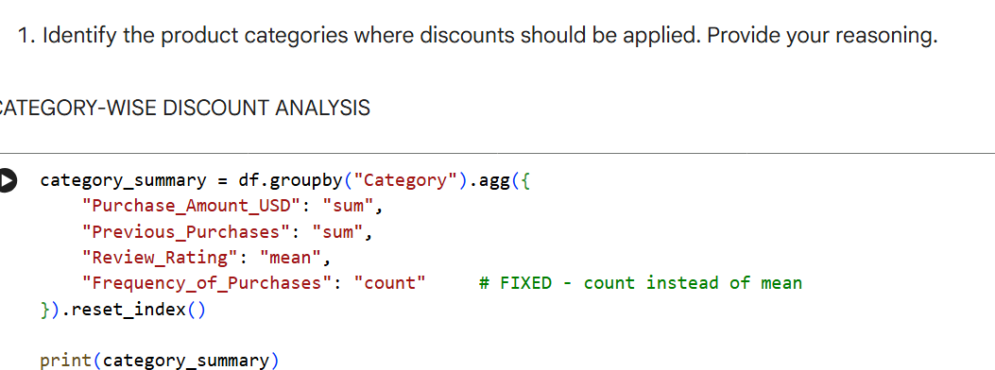
Output -
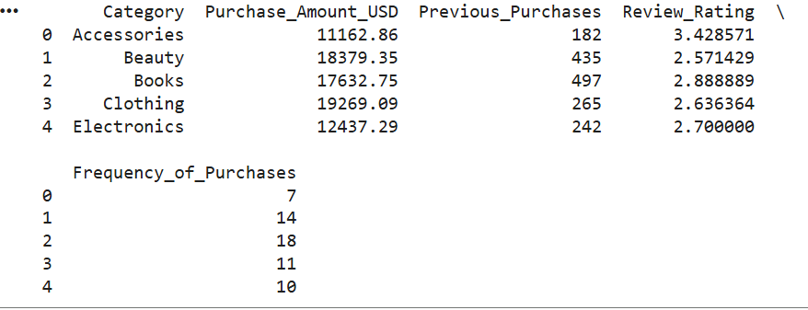
This code shows the highest average spending based on categories.
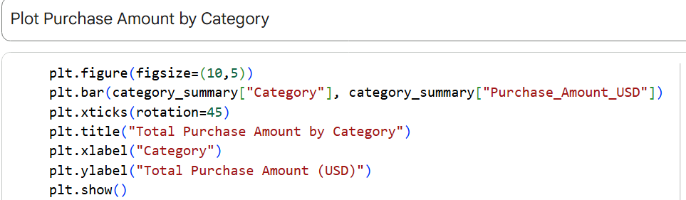

Output –
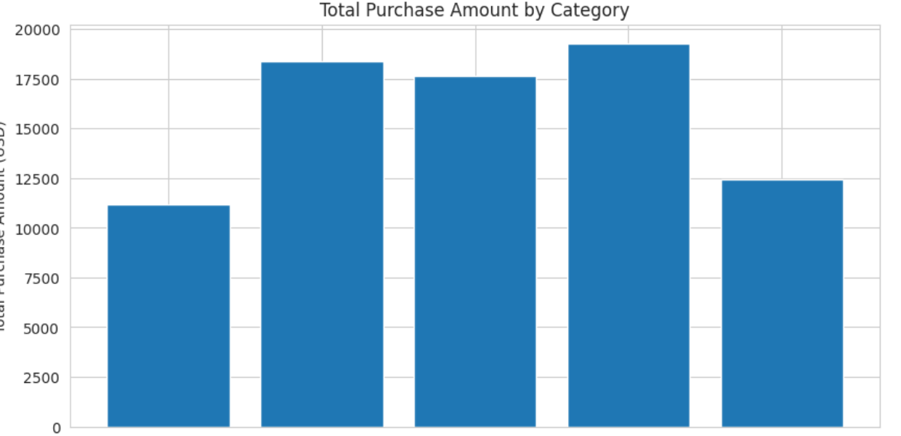
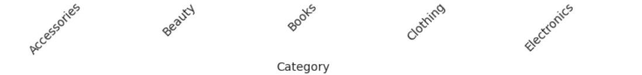
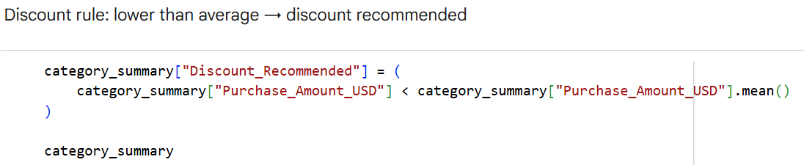
Output –
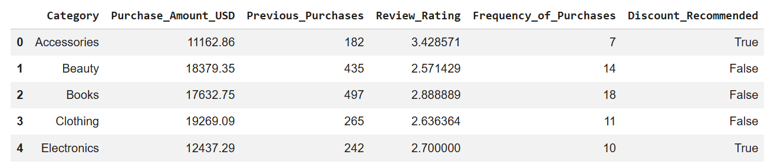
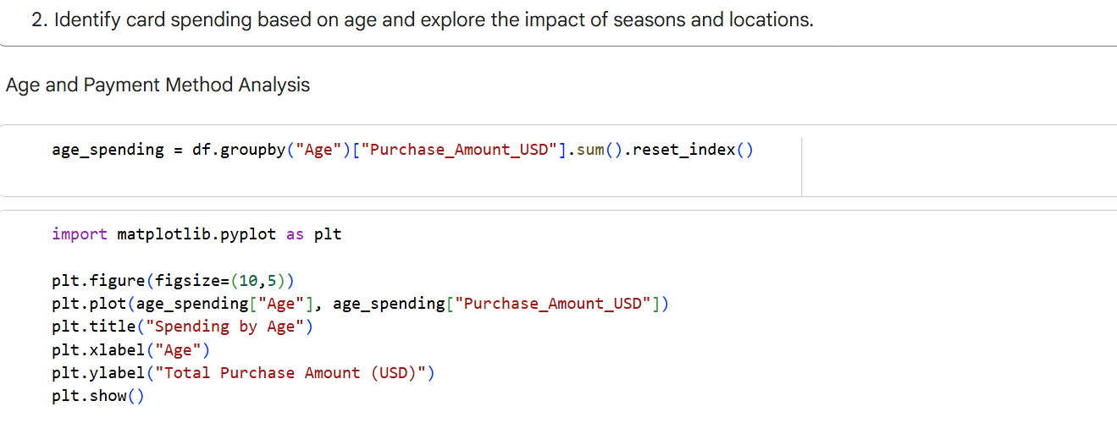
Output –
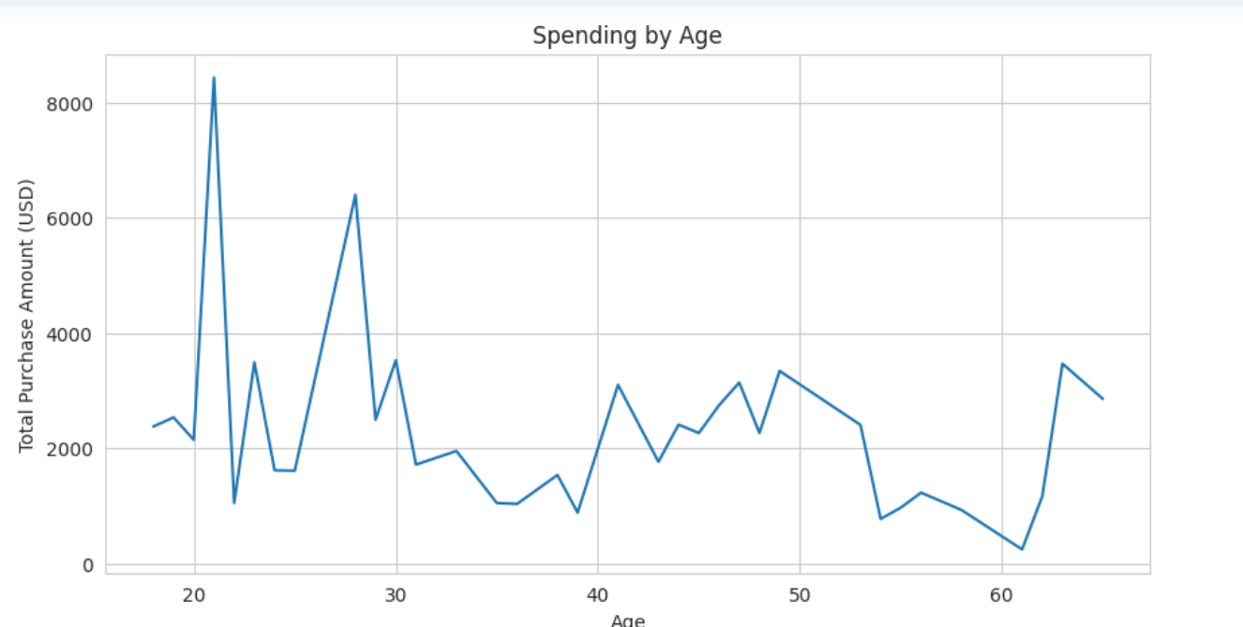
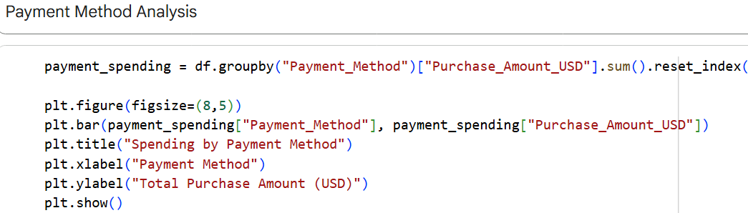
Output –
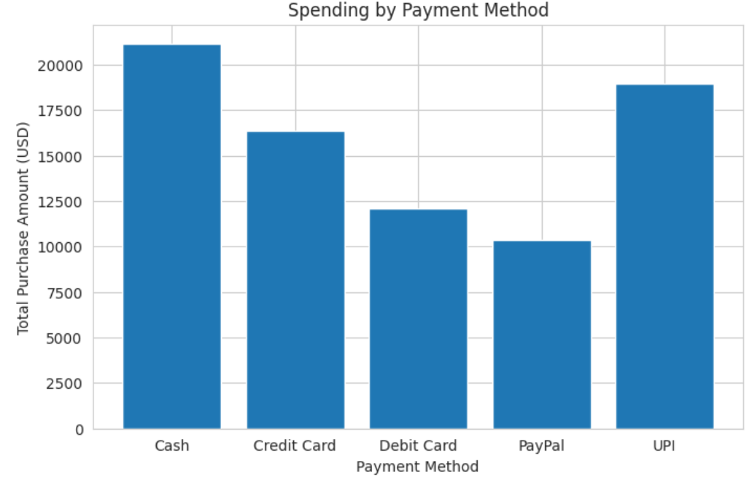
This code further creates groups and checks payment method preferences.

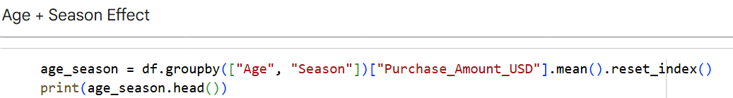
Output –
Age Season Purchase_Amount_USD
0 18 Summer 2375.64
1 19 Autumn 526.81
2 19 Summer 2007.35
3 20 Summer 2144.84
4 21 Autumn 1789.45
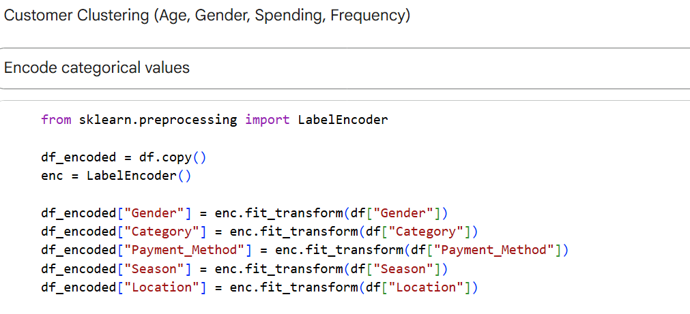
This code calculates the average purchase based on season and location.
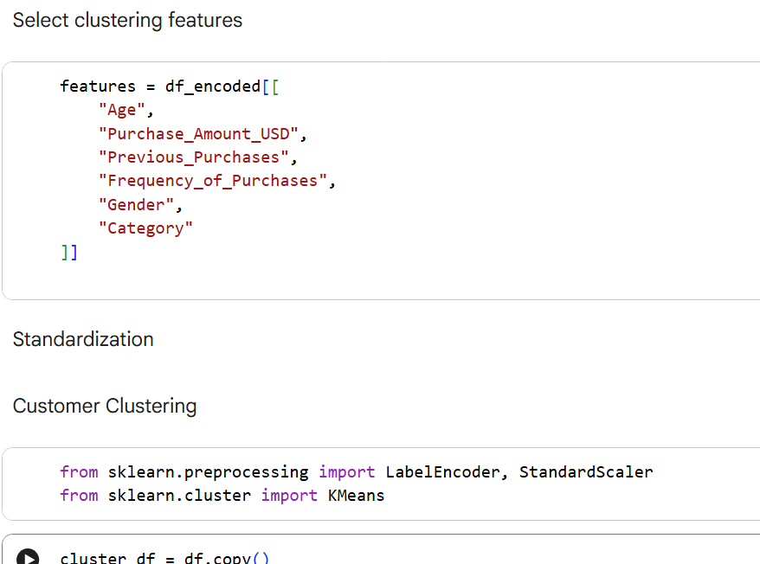
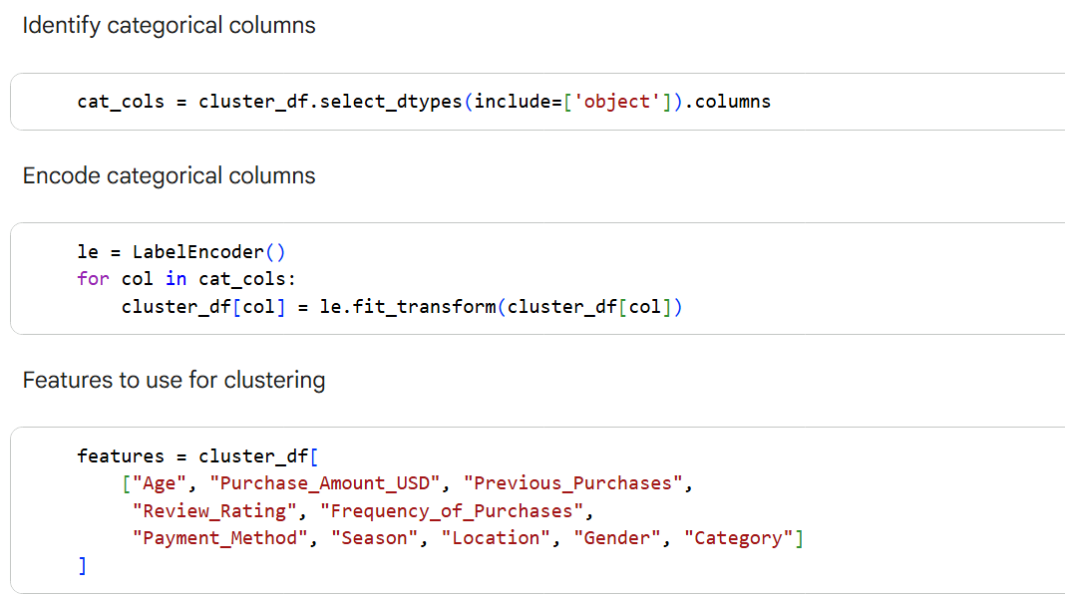
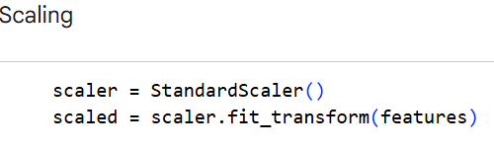
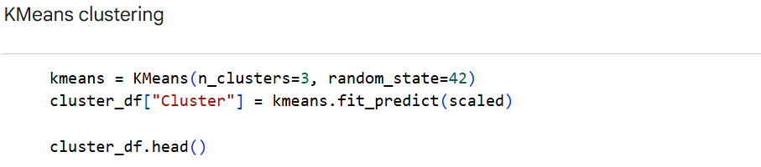
Output –
Purchase_Amount_USD | Item_Purchased | Category | Review_Rating | Subscription_Status | Previous_Purchases | Frequency_of_Purchases | Location | Season | Age | Gender | Payment_Method | Discount_Applied | Cluster
0 | 685.61 | 6 | 1 | 2 | 0 | 30 | 3 | 1 | 3 | 29 | 1 | 3 | 0 | 2
1 | 1670.70 | 8 | 2 | 2 | 1 | 50 | 0 | 3 | 2 | 29 | 0 | 4 | 0 | 0
2 | 1000.46 | 2 | 1 | 5 | 1 | 6 | 0 | 1 | 3 | 47 | 0 | 0 | 0 | 0
3 | 386.03 | 9 | 4 | 1 | 1 | 20 | 1 | 0 | 2 | 23 | 0 | 0 | 0 | 2
4 | 160.48 | 7 | 2 | 2 | 0 | 22 | 0 | 1 | 0 | 53 | 0 | 0 | 0 | 0
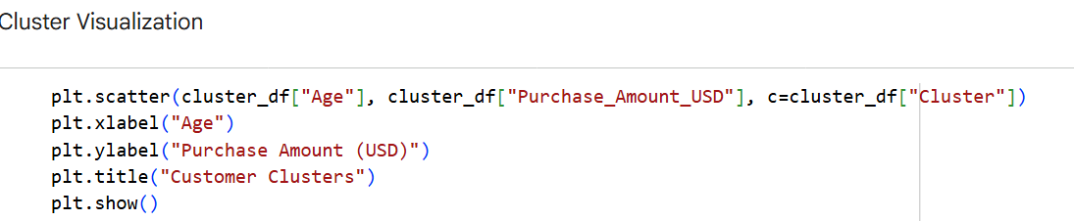
Output –
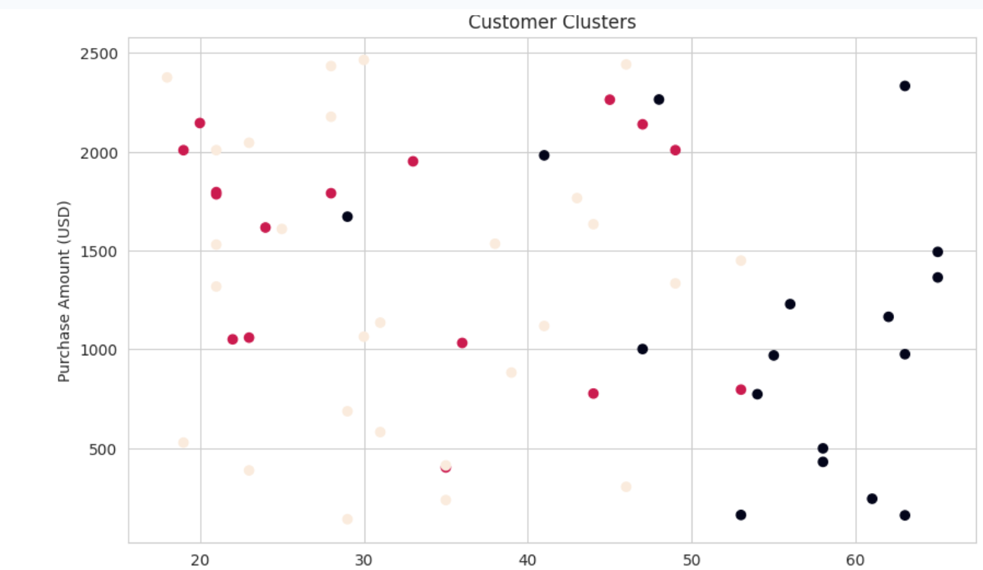
Age

This code scales the features and runs the final k-means model (assuming optimal k=4).

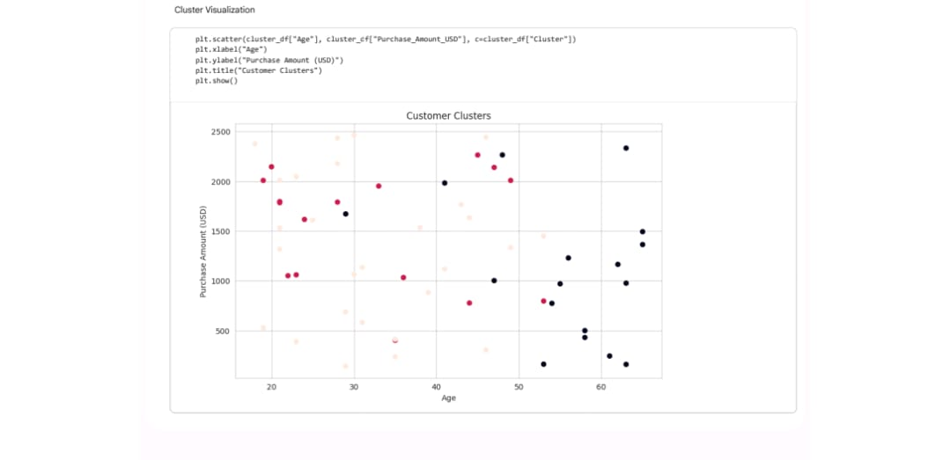

Conclusion :
In this project, we used the Shopping Trends dataset to understand customer shopping behavior. Analysis revealed that the Accessories and Electronics categories have low total spending, making it beneficial for the business to offer discounts in these categories. Spending varies with age, and customers shop more during certain seasons, such as summer and winter. Differences in locations also revealed that each city has a different shopping pattern.
We used the K-Means technique to divide customers into three distinct groups. Each group had a different shopping style, making it easier for the business to create targeted offers and promotions for each group.
Overall, this project demonstrated that data analysis helps businesses make better decisions—such as discount strategies, marketing plans, and understanding customer needs.

